ALT Flow Cell Flush Procedure

Items needed;
10cc syringe
1/16” diameter pinch tubing (from PM kit) cut into two pieces, one 16” and one 9” long.
1 small cup, 4-6 oz. is fine. (urine cup)
3 – 4 oz. of Windex brand window cleaner. (plain, no scents or whatever)
3 – 4 oz. of DI water
**(essential) 1 or 2 barbed fittings in case one breaks during line removal.

Before performing the flow cell flush procedure;
- drain the flow cell (Drain or first part of Prime)
- switch the control knob or button to standby
- de-pressurize the sheath tank
- turn the instrument off.

Step 1. Remove optics cover.

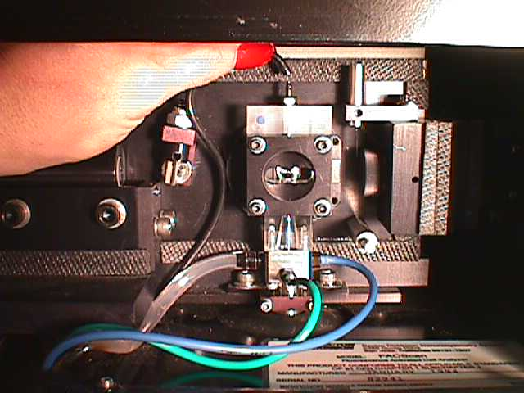
Step 2. Remove the black line from the barbed fitting on top of the flow cell.

Step 3. Remove the blue line from the barbed fitting on the right side of the flow cell.

Step 4. Place the longest tube on the top port of the flow cell with the other end hanging in a small cup containing approximately 1” of windex in the bottom.

Step 5. Place the shorter tube on the port where the blue line was connected.

Step 6. Fill the syringe half full of windex and place it on the end of the shorter tube.

Step 7. Gently pump windex back and forth through the flow cell with the purpose of creating bubbles by oscillating the flow. Perform at least 50 cycles back and forth. (heavy deposits will take longer)

Step 8. Flush with DI water to remove windex from flow cell. Don’t oscillate the flow.

Step 9. Reconnect the black and blue lines to their respective ports.

Step 10. Bring the instrument back up and check for leaks at the black and blue ports.

If you observe a leak, de-pressurize the sheath tank, disconnect the leaky connection, trim 1/8” from the end of the tubing and reconnect it. Pressurize the sheath tank and re-check connections.
Call 1-800-932-6883 if you have questions or need assistance.

